1133730206 李天宝 第三次作业

6.



10.

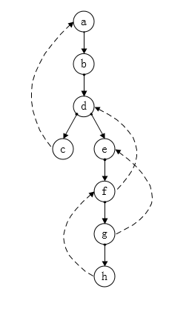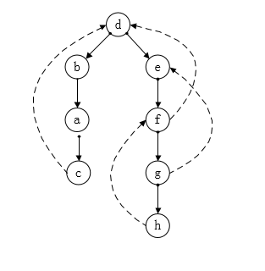

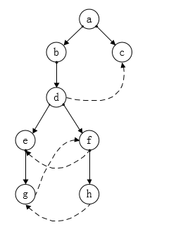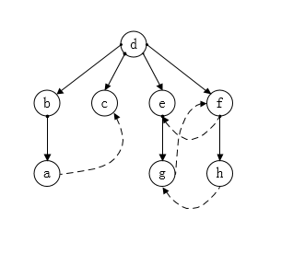

26.

|  |  |  |  |  |  |  |
| --- | --- | --- | --- | --- | --- | --- |
|  | 1 | 2 | 3 | 4 | 5 | 6 |
| 1 | 0 | 19 | 15 | 29 | 29 | 25 |
| 2 | 2 | 0 | 17 | 25 | 10 | 27 |
| 3 | 6 | 4 | 0 | 14 | 14 | 10 |
| 4 | ∞ | ∞ | ∞ | 0 | ∞ | ∞ |
| 5 | ∞ | ∞ | ∞ | 15 | 0 | ∞ |
| 6 | ∞ | ∞ | ∞ | 4 | 10 | 0 |

|  |  |
| --- | --- |
|  | 偏心度 |
| 1 | ∞ |
| 2 | ∞ |
| 3 | ∞ |
| 4 | 29 |
| 5 | ∞ |
| 6 | ∞ |

所以中心点为4

30.

void dfs()

{

stack <int> s;

bool visited[n];

memset(visited,0,sizeof(visited));

s.push(1);

visited[1]=1;

while(s.empty()==0)

{

int t=s.begin();

for(int i=1;i<=n;i++)

if(visited[i]==0&&dis[i][j]!=maxint)

{

cout<<i<<"->"<<j<<:<dis[i][j]<<endl;

visited[j]=1;

s.push(j);

}

s.pop();

}

}

44.

|  |  |  |
| --- | --- | --- |
|  | VE[i] | VL[i] |
| 1 | 0 | 7 |
| 2 | 5 | 12 |
| 3 | 8 | 9 |
| 4 | 12 | 15 |
| 5 | 15 | 15 |
| 6 | 16 | 19 |
| 7 | 16 | 16 |
| 8 | 19 | 19 |
| 9 | 21 | 21 |
| 10 | 23 | 23 |

|  |  |  |  |
| --- | --- | --- | --- |
|  | E[j] | L[j] | L[j]-E[j] |
| 1 | 0 | 7 | 7 |
| 2 | 0 | 0 | 0 |
| 3 | 5 | 12 | 7 |
| 4 | 6 | 6 | 0 |
| 5 | 6 | 12 | 6 |
| 6 | 12 | 12 | 0 |
| 7 | 12 | 19 | 7 |
| 8 | 12 | 12 | 0 |
| 9 | 15 | 16 | 1 |
| 10 | 15 | 15 | 0 |
| 11 | 16 | 19 | 3 |
| 12 | 16 | 16 | 0 |
| 13 | 19 | 19 | 0 |
| 14 | 21 | 21 | 0 |

关键活动：2, 4, 6, 8, 10, 12, 13, 14

关键活动有向图：

